Notice to parents of Grade 5 and 6 students

Mount Pearl Soccer Association will be hosting a FREE FUN SOCCER TOURNAMENT for kids of all skill levels and abilities as a part of the 2023 Frosty Festival. This tournament will be held on Saturday February 11th at Morris Academy on Roosevelt Ave.

If your child wishes to participate for their school’s team, please complete the form below and send it officemanager@mpsa.ca Subject: Frosty Soccer 2023

Deadline for registration is Monday January 23rd
The schedules will be posted by February 3rd on the MPSA website (www.mpsa.ca). As this year’s tournament will be condensed to one day, space and games are limited.
Please print
Child’s name__________________________________
Child’s School_________________________________
Grade________________ Gender________________
Parent’s name_________________________________
Parent’s contact information(email and telephone):
________________________________________________________
________________________________________________________
Allergies / Medical concerns __________________________________

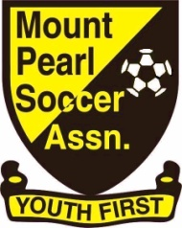
Intersted in voluteering or coaching yes____ no____

