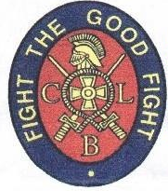
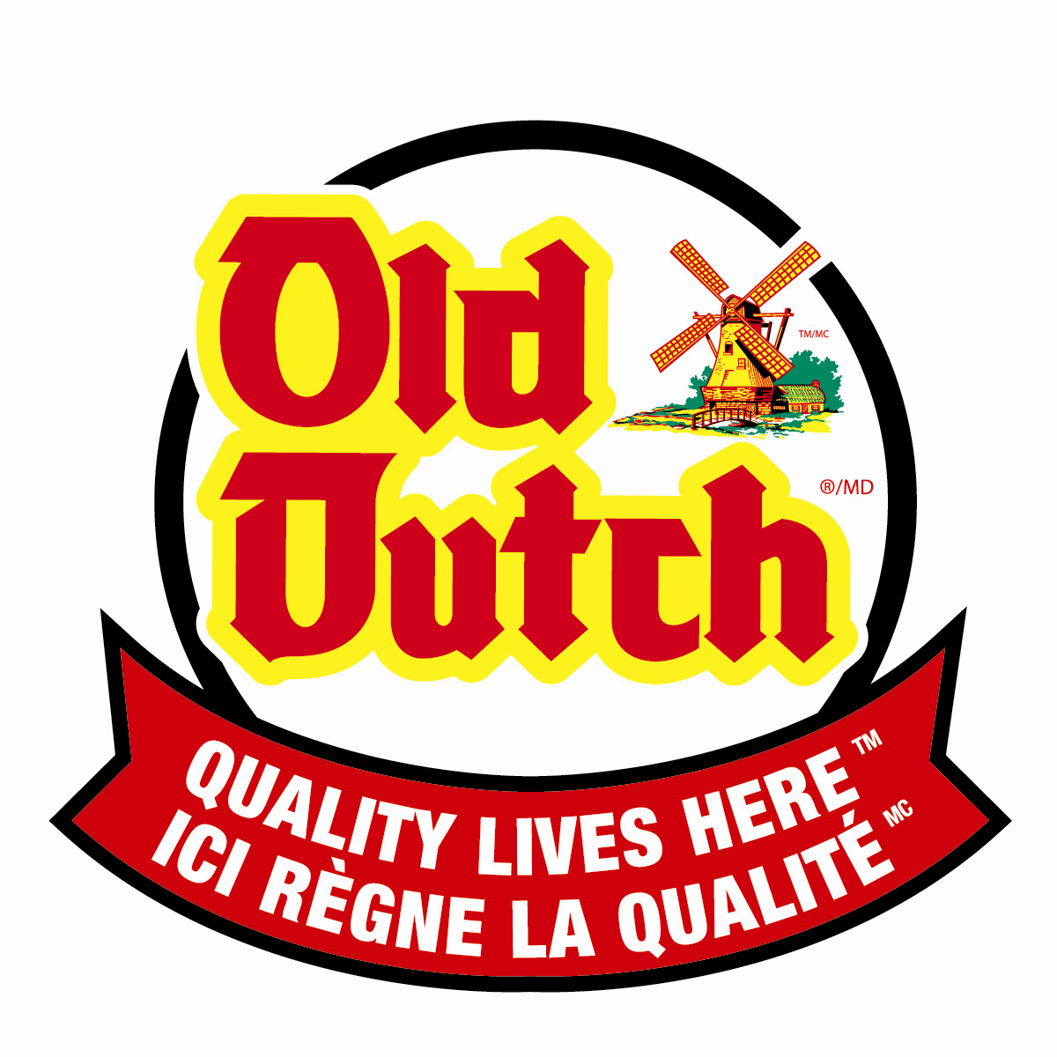
Deadline extended till January 26, 2023

MOUNT PEARL FROSTY FESTIVAL
OLD DUTCH LIP SYNC – Mt. Pearl CLB
Monday, February 13, 2023
(***Please complete only ONE form per Act***)

Name: ______________________________________________________
Address: ______________________________________________________
School: ______________________________________________________
Telephone: ________________________________
Email: ____________________________________________
Song Title: ___________________________________________________________

Each group is limited to six members:
1. _______________________________ 3. _______________________________
2. _______________________________ 4. _______________________________
5. _________________________ ______ 6. _______________________________
Please send your video and REGISTRATION FORM to: craigjamesdyer@gmail.com
Subject: Frosty Lip Sync 2023.

Rules:

- Contestants must provide their own music and if required musical equipment and props. Please label your IPOD, PHONES, Etc.
- Eliminations will be held on Sunday, January 12, 2023 at Church of the Ascension, Smallwood Dr.
3. Contestants will be judged on originality, costume, choreography, and synchronization.
4. Prizes will be awarded for three age categories (age categories subject to change depending on registration)

5-7 years 8-10 years 11 plus

Please note the following:
This is a lip sync competition. While marks are given for costume and props; contestants are graded mostly on how well they know their song.

